***Software Requirements Specification for mobattend by Teratech***

Software Requirements Specification

for

**Mobile Attendance Checking**

**(Mobattend)**

Version 1.0

Prepared by Teratech

Apau-Twerefuor Akua

Awuah Baffour Prince

Jephter Danso Kumuyi

Charles Asamoah

Edward Banson

Gregory Aidoo

Andrews Adade

Michael Tetteh

Richard Obeng Opuni

Samuel Brefo

Samuel Asiedu

Date : 7th February, 2017

# INTRODUCTION

Teratech’s software serves lecturers and teachers of various departments and schools by providing them with easy access to students information. As a company, we have seen the need to develop a mobile application (mobattend) to aide lecturers and teachers in taking attendance before class starts.

**Document Purpose**

It is the purpose of the app to provide lecturers and teachers a way to take the attendance for a class without taking a lot of time and without mishaps.

Mobattend is a application. Currently, the version 1.0 prototype is underway, with initial designs being laid out. This SRS covers the entire application, from front end, Graphical User Interface to how information would be accessed and its database system.

**Product Scope**

Mobattend is designed to provide support for lecturers and teachers. The primary benefit of the application is that teachers can take attendance without any problems, and be able to get access to all previous information easily. Lecturers therefore will be able to see the number of times a student has been in class with just a click.

The goal of the app is that lecturers will be able to take attendance with their phone by clicking in or out and every detail will be taken and all necessary additions and subtractions are done immediately. It also has

**Intended Audience and Document Overview**

Mr. Jephter Yankey, the project overseeing lecturer is intended to be the audience . The document is intended as a means for him to easily see and refer to our overall product goals and commitments. It also serves a secondary purpose of allowing the project team to make sure that intended goals and functionalities of the product are being met.

***Definitions, Acronyms and Abbreviations***

API : Application Programming Interface

DB : Database

Mobattend : mobile attendance

***References and Acknowledgements***

https://www.google.com.gh/url?sa=t&source=web&rct=j&url=http://www.csc.villanova.edu/~tway/courses/csc4181/s2010/srs_template-1.doc&ved=0ahUKEwiViaHyqYLSAhUUM8AKHY3uBDsQFggYMAA&usg=AFQjCNH5RCUtifVhnKm9Kfwnx6_Z2T5LzA&sig2=6eL1A9E2Ns2RiWTrl7h8QQ

## Overall Description

**Product Perspective**

Mobattend is a self-contained application. It operates on Android systems. Mobattend needs to obtain information about the user, the application queries lecturers for information about students, e.g. Students class, name, index numbers , in order to complete its primary purpose of helping lecturers take attendance and record its frequency .

(PICTURE OF THE PAGES INDICATING DEPARTMENT AND COURSE, MAYBE. FOR BOTH ANDROID AND WINDOWS PLATFORMS.)

***Product Functionality***

Major Functions:

* Allows lecturers to record students’ attendance themselves without much time consumption.
* Allows the lecturers to have a statistical view of how the students of a class are responding to his lectures.
* Lecturers can get reminders of the upcoming classes.

**Users and Characteristics**

Mobattend will be used by:

**Lecturers and teachers**: They will provide students information and as they attend lectures record the student attendance.

**Operating Environment**

The Mobattend client requires a device running Android, interface. (???)

**Design and Implementation Constraints**

(Since Mobattend is a mobile application designed to work with ???)

**User Documentation**

User documentation for Mobattend would be minimal. A help Dropbox available publicly on the app should be sufficient to answer any questions users have. Additionally, support via email would be made available.

Issues with unresponsiveness of the application are incumbent on the owner/user of their phone to read their phone’s manual or to contact the manufacturer.

**Assumptions and Dependencies**

(.???)

### Specific Requirements

* 1. **External Interface Requirements**
     1. 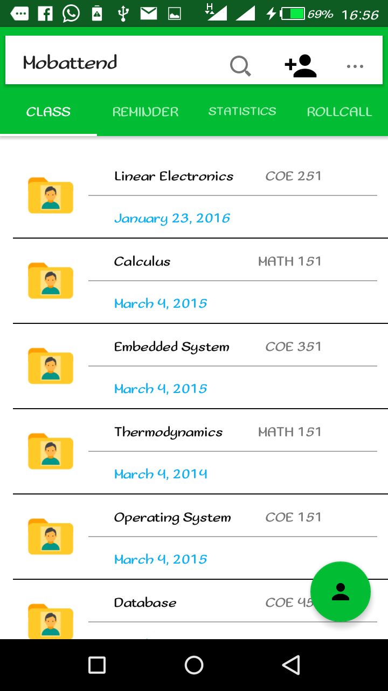**User Interfaces**

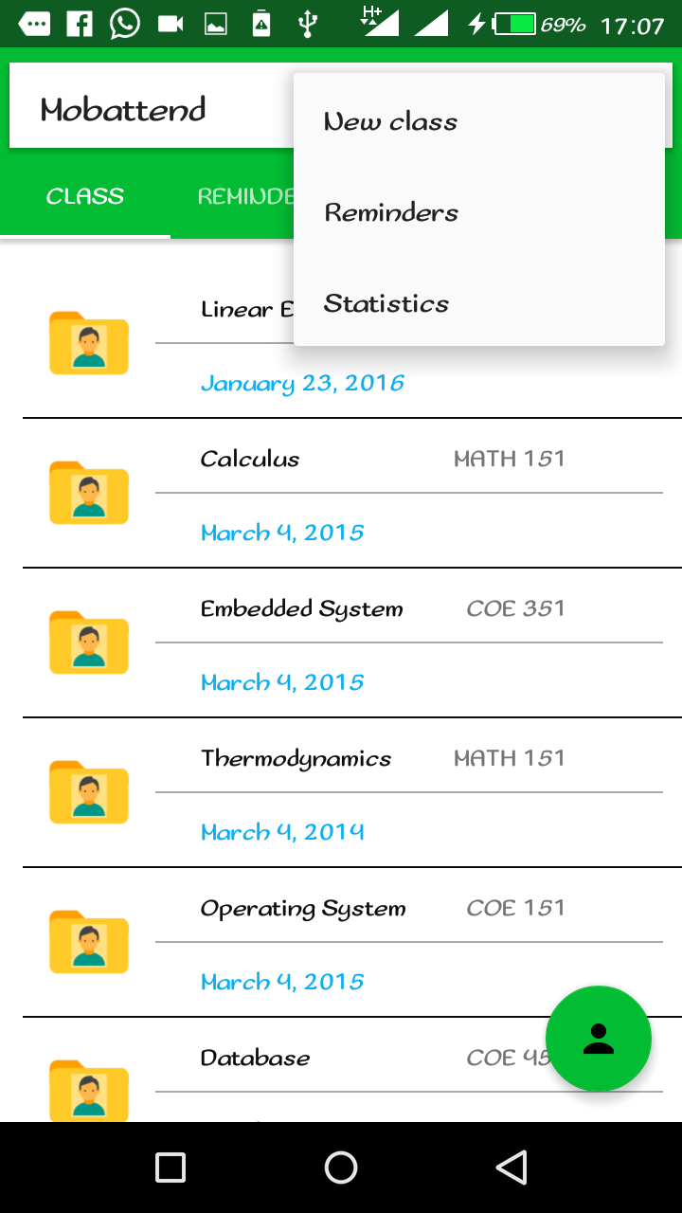

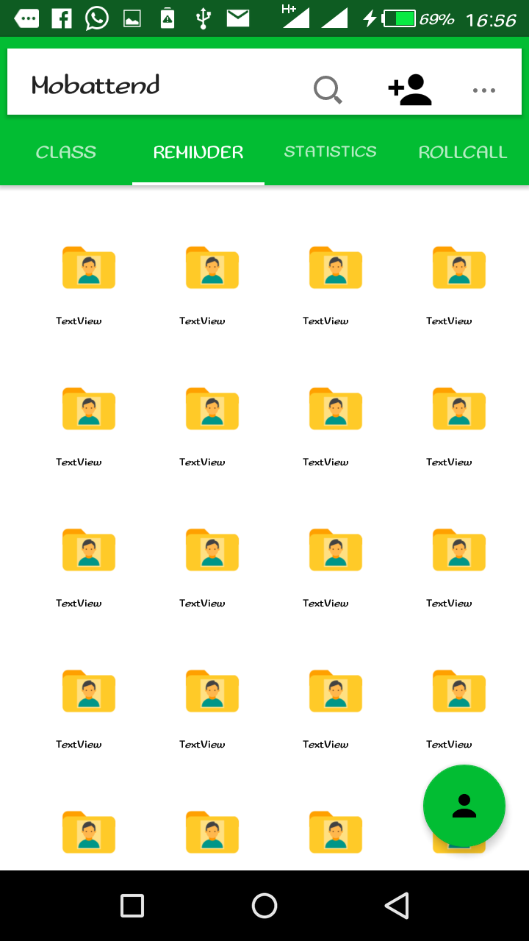

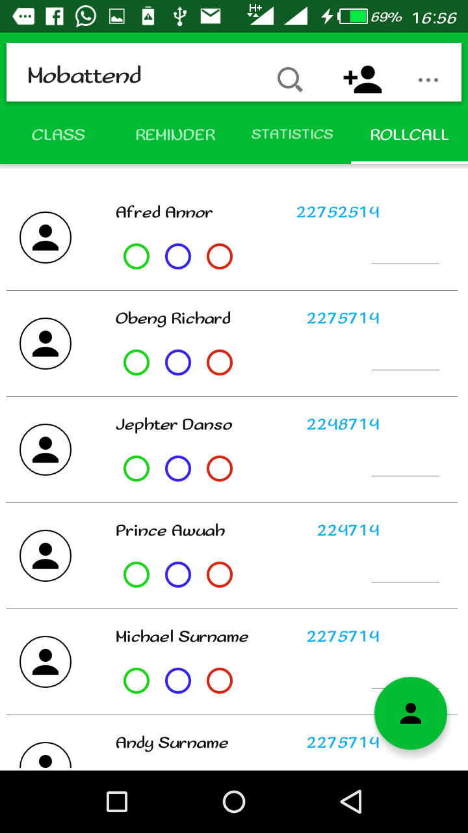

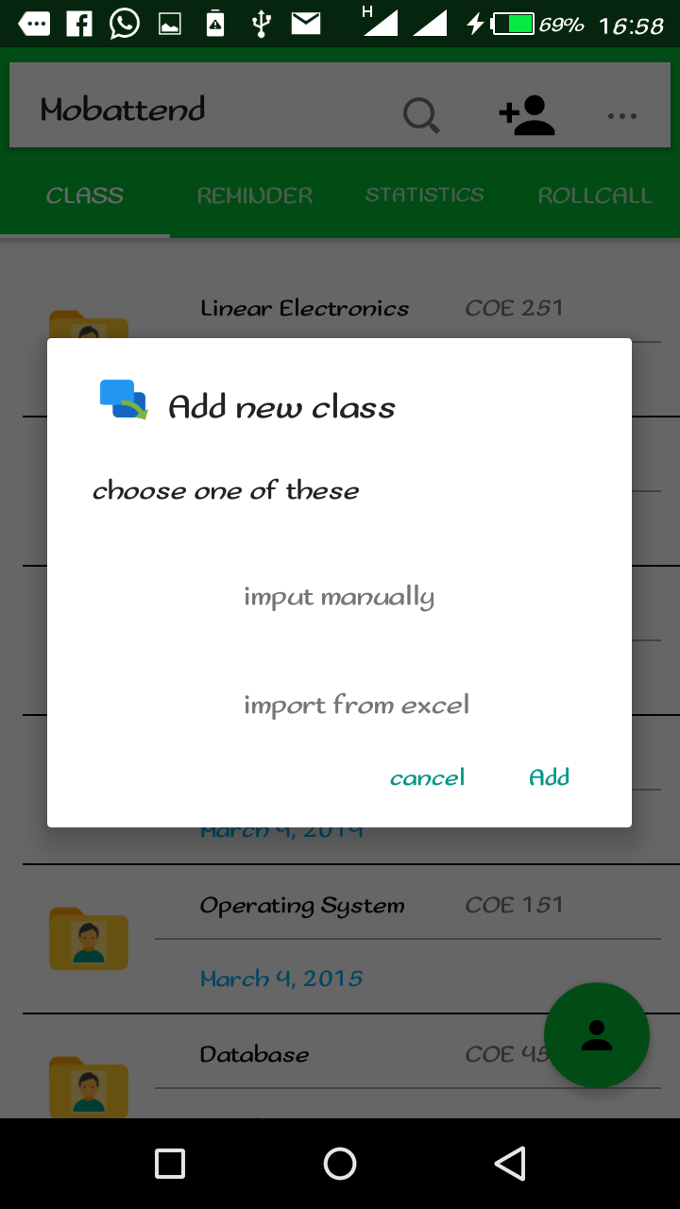

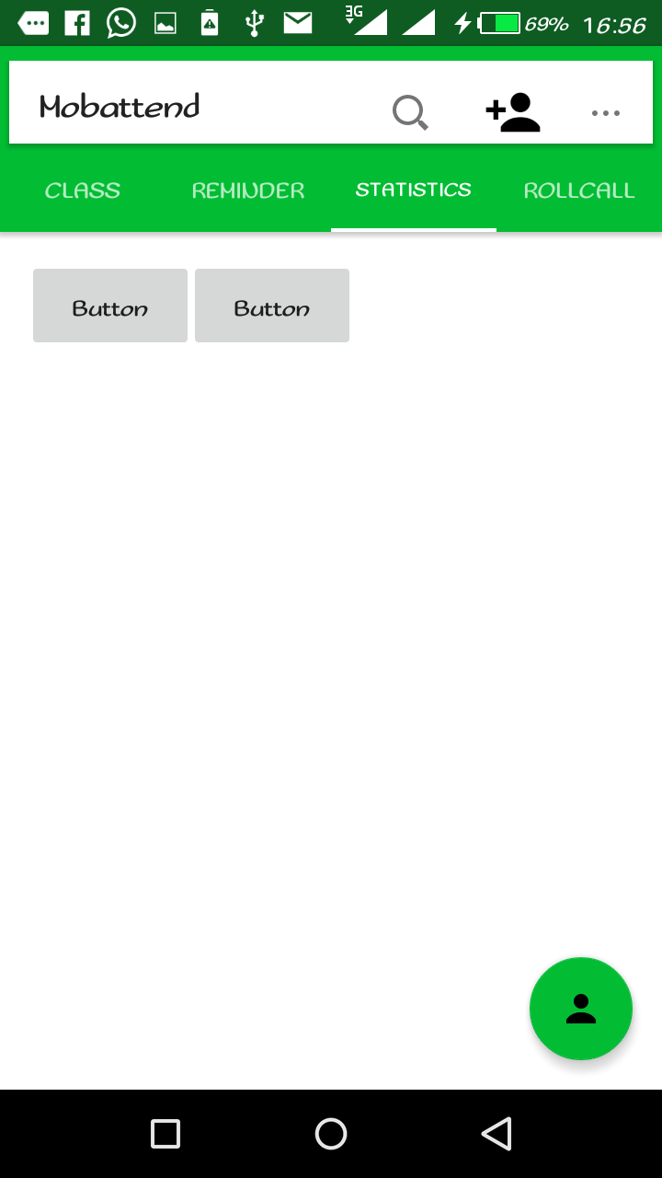

* + 1. **Software Interfaces**
  1. **Functional Requirements**
  2. **Behavior Requirements**

1. **Other Non-Functional Requirements**
   1. **Safety and Security Requirements**

* Encryption???

**Appendix A – Data Dictionary**

(Future versions of this document will contain data dictionary items)

**Appendix B – Group Log**

(Included here are all the minutes from our group meetings, our group activities, and any other relevant information that will assist the lecturer in determining the effort put forth to produce this document.)

Group meetings:

04/02/2017 2:00 – 5:30 pm. Began discussions on how to carry out our SRS write up.

07/02/2017 4:20 - 5:45 pm. Discussion on database design and it implementation.

* PM spelled out how the database design will be and showed the normalised aspects